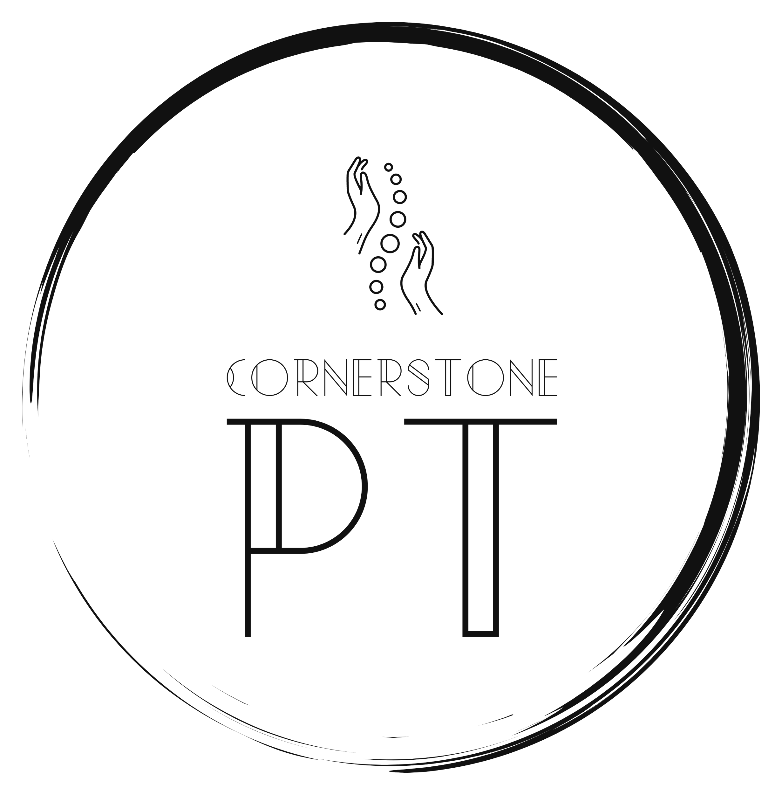 | Cornerstone PT, PLLC  401-307-3389  KBAKER@cornerstoneptfl.com

What is physical therapy?

The Oxford dictionary defines physical therapy as the treatment of disease, injury, or deformity by physical methods such as massage, heat treatment, and exercise rather than by drugs or surgery.

The American Physical Therapy Association (APTA) describes a physical therapist as movement experts who improve quality of life through prescribed exercise, hands-on care, and patient education.

As a physical therapist, we treat patients of all ages and with injuries or limitations connected to human movement, as well as general health/fitness, to prevent injuries. Most physical therapists have over 6+ years of education resulting in a doctorate of physical therapy. With years of training in the musculoskeletal, neuromuscular, and socioeconomic impacts on human movement, we are very well suited to help clients with our movement expertise.

If you have questions about what a physical therapist can do, or if we could help you with your current limitations or injury, please contact us today!

